Erlestoke Parish Council – Precept Options 2026/27
Running costs: £7,709.63
3-month reserve ≈ £1,927
6-month reserve ≈ £3,855

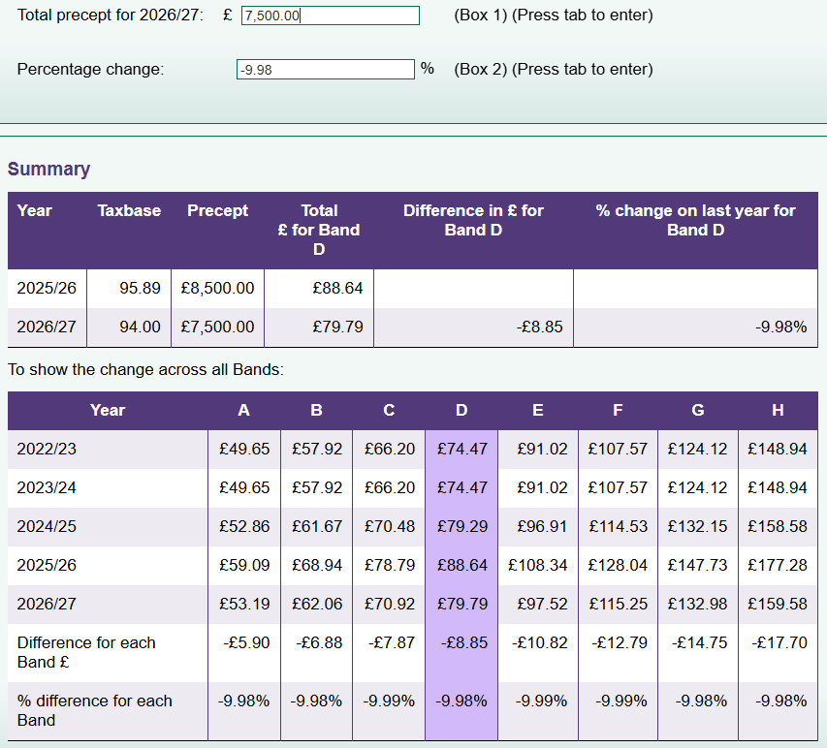
Starting Position:
At the end of the current financial year, the council’s projected bank balance is approximately £10,324, after paying the remaining White Gates project and outstanding running costs. The council has earmarked reserves of £15,300 for planned projects, including community improvements, SIDs, tree surveys, election costs, and a new swing.
Please see the budget comparison and earmarked reserve allocations spending at the end of the document.
Option 1 – Precept £7,500
Financial Overview
- Running Costs: £7,454.63
- Earmarked Reserves: £15,300
- Total Expenditure: £22,754.63
- Projected Year-End Balance: –£5,030.30
- Council Reserve if all earmarked projects were spent immediately: –£5,030.30
Implications:
- Running costs would be fully covered, but there would be no funds available if all earmarked projects were spent in the same year.
- Any unexpected costs, such as urgent playground repairs or emergency tree work, would need to be funded from additional sources or delayed projects.
- This option keeps the precept low for residents but leaves the council with very limited financial flexibility.
Recommendation:
- Not recommended. I believe it is financially risky and limits the council’s ability to respond to unforeseen needs.
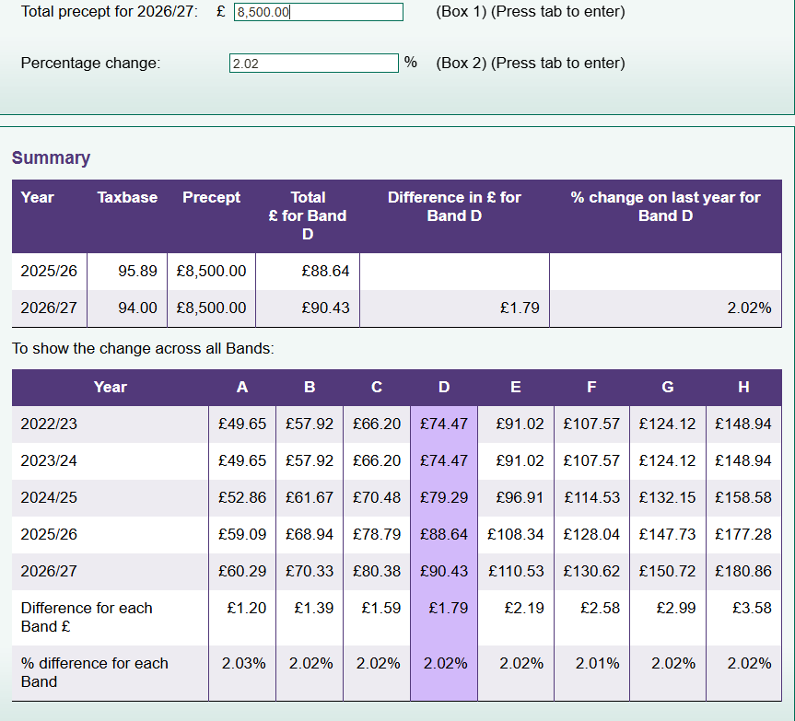
Option 2 – Precept £8,500
Financial Overview:
- Running Costs: £7,454.63
- Earmarked Reserves: £15,300
- Total Expenditure: £22,754.63
- Projected Year-End Balance: –£4,030.30
- Council Reserve if all earmarked projects were spent immediately: –£4,030.30
Implications:
- Running costs are fully met, and the council makes a small contribution toward rebuilding reserves.
- If all earmarked projects were funded immediately, the council would still have a shortfall, though smaller than Option 1.
- There is some improvement in financial resilience, but unexpected costs would still be challenging.
Recommendation:
- Moderately conservative. Suitable if the council prefers to gradually rebuild reserves over time, keeping the precept affordable for residents, but does not leave room to spend much of the ear marked reserves.

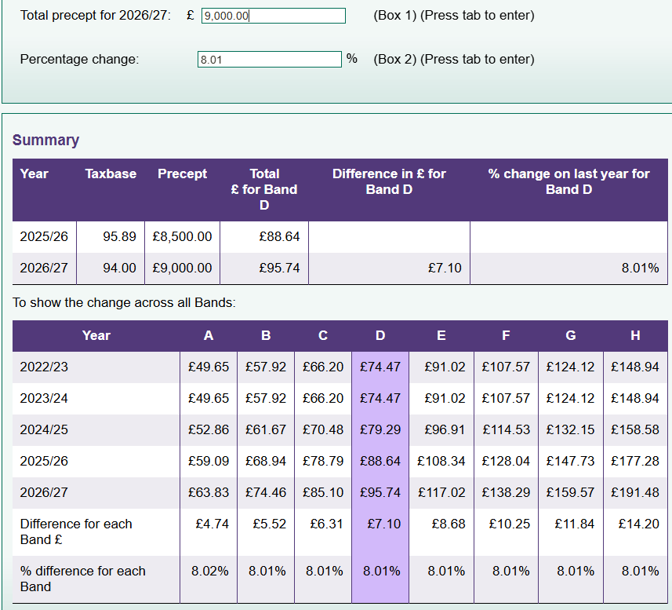
Option 3 – Precept £9,000 (Recommended)
Financial Overview:
- Running Costs: £7,454.63
- Earmarked Reserves: £15,300
- Total Expenditure: £22,754.63
- Projected Year-End Balance: –£3,430.30
- Council Reserve if all earmarked projects were spent immediately: –£3,430.30
Implications:
- Running costs are fully met, and the precept allows a larger contribution toward reserves than the lower options.
- If all earmarked projects were funded in the same year, the council would still have a shortfall, but it is smaller, giving slightly more flexibility.
- This approach balances responsible financial management with affordability for residents.
Recommendation:
- Preferred option. It supports gradual reserve rebuilding while maintaining financial stability, and allows consideration for annual inflation rises

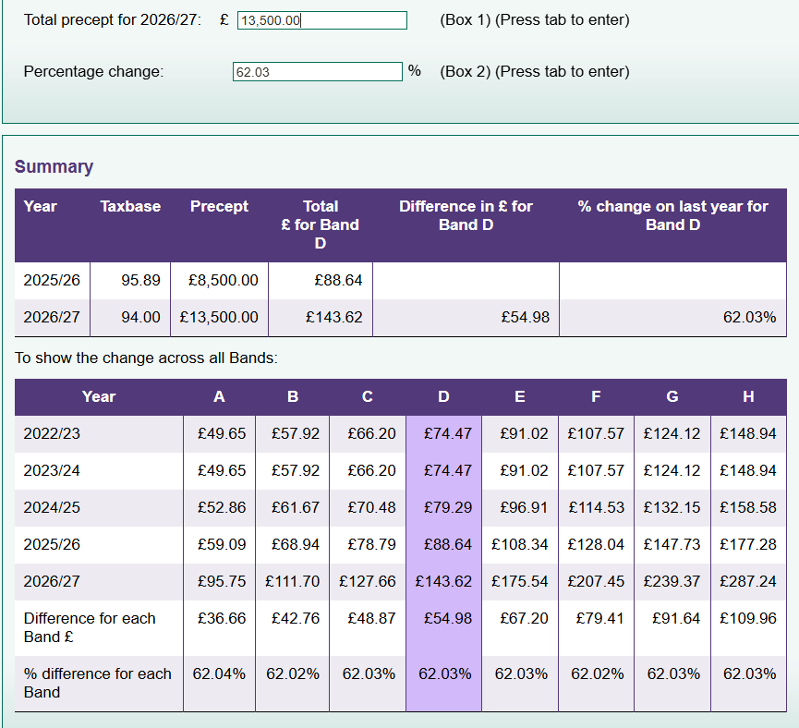
Option 4 – Precept £13,300
Financial Overview:
- Running Costs: £7,454.63
- Earmarked Reserves: £15,300
- Total Expenditure: £22,754.63
- Projected Year-End Balance: £869.70
- Council Reserve if all earmarked projects were spent immediately: £869.70
Implications:
- Running costs and all earmarked projects could be funded in the same year without going overdrawn.
- The council would have a small positive general reserve, providing real resilience for emergencies or unexpected costs.
- Residents would see a significant precept increase, which may be considered high relative to the parish size.
Recommendation:
- Most secure option. Ideal if the council wishes to fully fund earmarked projects and establish a small positive reserve, but councillors should weigh the impact on residents.

Summary
- Low precepts (£7,500–£8,500): Affordable for residents, but leave council reserves negative if all projects were spent.
- Moderate precept (£9,000): Covers running costs and contributes toward rebuilding reserves; preferred for balance of affordability and stability.
- High precept (£13,300): Fully funds projects and creates a positive reserve, but is a significant increase for residents.
Precept | Total Running Costs | Earmarked Reserves | Total Expenditure | Projected Balance (Bank + Precept – Total Expenditure) | Council Reserve (Balance – if council spent all the Earmarked Reserves)
£7,500 | 7,454.63 | 15,300 | 22,754.63 | 10,324.33 + 7,500 – 22,754.63 ≈ –5,030.30 | –5,030.30
£8,500 | 7,454.63 | 15,300 | 22,754.63 | 10,324.33 + 8,500 – 22,754.63 ≈ –4,030.30 | –4,030.30
£9,000 | 7,454.63 | 15,300 | 22,754.63 | 10,324.33 + 9,000 – 22,754.63 ≈ –3,430.30 | –3,430.30
£13,300 | 7,454.63 | 15,300 | 22,754.63 | 10,324.33 + 13,300 – 22,754.63 ≈ 869.70 | 869.70

Table to show a Breakdown of the Above Numbers

Erlestoke Parish Council Budget Comparison 2025/26 – 2026/27 (4% inflation)
Item | Budget 2025/26 | Budget 2026/27
Running Costs
Clerk Salary | £2,800.00 | £2,912.00
Clerk Training (CILCA) | £450.00 (not spent) | £500.00
Home Working Allowance | £312.00 | £324.48
Insurance and Legal Fees | £403.53 | £419.67
Internal Audit Fees | £200.00 | £200.00
Mileage | £20.00 | £20.00
Clerk Administration (inc postage/stationery and WFH allowance) | £300.00 | £312.00
ICO | £35.00 | £45.00
Extras | £175.00 | £182.00
Play Equipment Inspection | £117.31 | £122.00
Membership | £270.00 | £281.00
Grass Cutting | £1,600.00 | £1,664.00
Website and Domain | £262.00 | £272.48
Meeting Room Rental | £200.00 | £200.00
Total Running Costs | £7,294.84 | £7,454.63
Earmarked Reserves
Community Projects (Playground) | £4,000.00 | £1300
White Gates Speed Plan | £1,500.00 | £2700 (actual cost, some money moved from the community project fund above)
SIDs / Traffic Programme | £3,500.00 | £3,500.00
Tree Survey and Upkeep | £1,000.00 | £1,000.00
Election Costs | £1,000.00 | £300.00
New Swingset | – | £5,000.00
Total Earmarked Reserves | £11,000.00 | £15,300.00
Total Budget (Running Costs + Earmarked Reserves) | £18,294.84 | £22,754.63
Precept | £8500 | £8,500.00 (current)
Current Council Money / Savings | £10,739.23 | £14,709.33 (this does not include the costs up till April, which would be £10324)
Section 137 Community Donations | To be determined | To be determined

Earmarked Reserve Allocation (Proportional Example)
Project | Total Required | Actual Cost / Planned Payment | £7,500 Precept | £8,500 Precept | £9,000 Precept | £13,300 Precept
Community Projects (Playground) | 4,000 | 1,300 | 1,300 | 1,300 | 1,300 | 1,300
White Gates Speed Plan | 1,500 | 2,700 | 2,700 | 2,700 | 2,700 | 2,700
SIDs / Traffic Programme | 3,500 | 3,500 | 3,500 | 3,500 | 3,500 | 3,500
Tree Survey and Upkeep | 1,000 | 1,000 | 1,000 | 1,000 | 1,000 | 1,000
Election Costs | 1,000 | 300 | 300 | 300 | 300 | 300
New Swingset | – | 5,000 | 0 | 0 | 0 | 5,000
Total Funded | 15,300 | 15,300 | 8,800 | 8,800 | 8,800 | 14,800
Unfunded / Shortfall (projects we cannot spend on without going into debt) | – | – | 6,500 | 6,500 | 6,500 | 500
Projected Bank Balance After Spending | – | – | 0 | 0 | 0 | 869.7

*Proportional allocation of remaining funds to swingset after funding higher-priority projects in full.
** Please note planned Whitegates should be coming out of this years budget, however there has been a delay, so I have included it in next years budget incase, and half would come from the community project as the projected cost is 2700
*** Recommended to keep a small amount available for an emergency election, this years costs were £250

